Ex.no:7b | DATA VISUALIZATION USING TABLEAU-  FASHION PRODUCTS ANALYSIS

Aim

To connect, analyze, visualize, and create an interactive dashboard using Tableau with the Fashion Products Analysis Dataset to analyze product pricing patterns, brand-wise product distribution, category-wise distribution, ratings, colors, sizes, and the factors influencing product performance.

Software Requirements

• Tableau Desktop / Tableau Public
• Microsoft Excel
• CSV Dataset
• Windows Operating System

Theory

Tableau is a powerful Business Intelligence (BI) and Data Visualization tool used to create interactive dashboards and reports.

The Fashion Products Analysis Dataset contains information related to fashion products, including product name, brand, category, price, rating, color, and size. Tableau can be used to analyze product pricing, brand-wise and category-wise distribution, ratings, and other product patterns through interactive visualizations and dashboards.

The dataset includes:
- User ID
- Product ID
- Product Name
- Brand
- Category
- Price
- Rating
- Color
- Size

Tableau allows users to analyze this data and identify brand-wise product patterns, category-wise distribution, price variations, rating patterns, color-wise distribution, and size-wise product trends.

Tableau Architecture
Fashion Products Analysis Dataset
↓
Data Connection
↓
Worksheets
↓
Visualizations
↓
Dashboard
↓
Story

Learning Outcomes

After completing this experiment, students will be able to:

✓ Connect the Fashion Products Analysis Dataset to Tableau.

✓ Create worksheets using dimensions and measures.

✓ Generate different charts and visualizations.

✓ Analyze product price patterns.

✓ Compare products across brands and categories.

✓ Analyze category-wise product distribution.

✓ Analyze color-wise and size-wise product distribution.

✓ Apply filters and parameters.

✓ Create calculated fields such as average price and average rating.

✓ Build interactive dashboards.

✓ Create stories for fashion product analysis.

Sample Dataset

Fashion Products Analysis Dataset

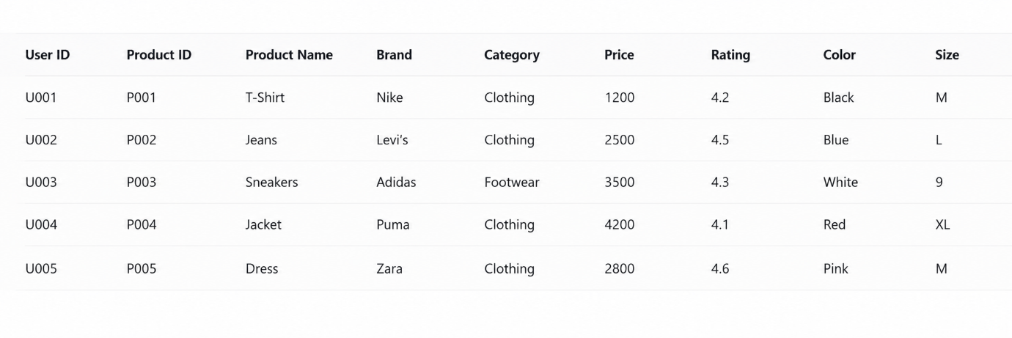

Algorithm 1 – Connecting Data Source

Step 1

Open Tableau Desktop.

Step 2

Select Connect.

Step 3

Choose Microsoft Excel or Text File depending on the dataset format.

Step 4

Browse and select the Fashion Products Analysis Dataset.

Step 5

Open the dataset.

Step 6

Verify the imported fields such as:
- User ID
- Product ID
- Product Name
- Brand
- Category
- Price
- Rating
- Color
- Size

Procedure

Tableau

↓

Connect

↓

Excel / Text File

↓

Fashion Products Analysis Dataset

↓

Open

↓

Verify Data

Output

Fashion Products Analysis Dataset loaded into Tableau successfully.

Algorithm 2 – Creating Worksheet

Step 1

Open Sheet 1.

Step 2

Drag Brand to Rows.

Step 3

Drag Price to Columns.

Step 4

Select Bar Chart from the visualization options.

Step 5

Enable Show Mark Labels to display the average price for each brand.

Step 6

Sort the brands in descending order based on Average Price.

Step 7

Add the title Average Product Price by Brand.

Output

Worksheet created successfully.

Interpretation

The bar chart displays the average product price for each brand. It helps compare pricing levels across different brands and identify the brands with the highest and lowest average product prices.

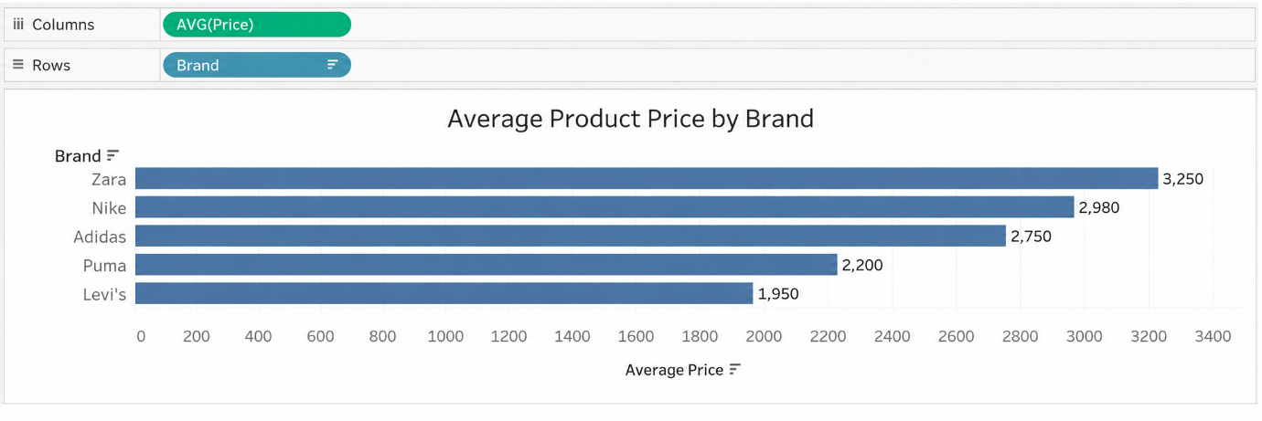

Algorithm 3 – Bar Chart Creation

Objective

To compare the average product price across different brands.

Step 1

Drag Brand → Rows.

Step 2

Drag Price → Columns.

Step 3

Select Bar Chart from Show Me.

Step 4

Enable Show Mark Labels.

Step 5

Sort the brands in descending order based on Average Price.

Output Visualization

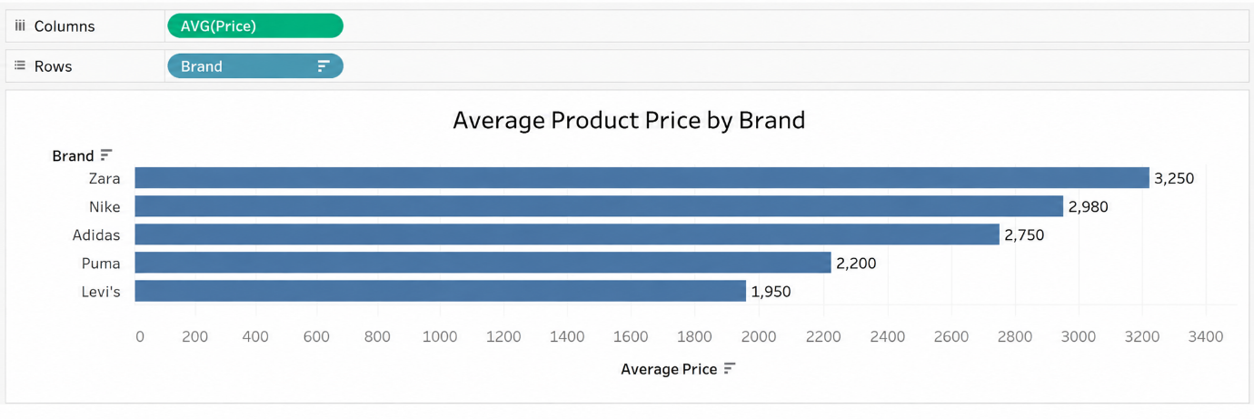

Interpretation

The bar chart helps identify restaurants generating higher and lower amounts of food waste.

Algorithm 4 – Pie Chart Creation

Objective

To analyze the distribution of products based on different categories.

Step 1

Drag Category to the view.

Step 2

Select Pie Chart from Show Me.

Step 3

Drag Product ID to Angle and select Count.

Step 4

Drag Category to Color.

Step 5

Enable Show Labels.

Output Visualization

Product Distribution by Category Pie Chart

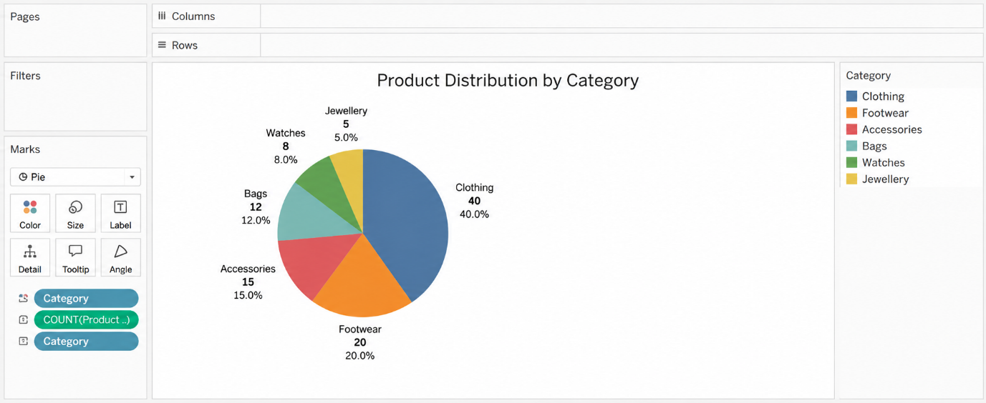

Interpretation

The pie chart shows the distribution of different product categories in the Fashion Products Analysis dataset. It helps identify the categories with the highest and lowest number of products.

Algorithm 5 – Line Chart Creation

Objective

To analyze the variation in average product price across different brands.

Step 1

Drag Brand → Columns.

Step 2

Drag Price → Rows.

Step 3

Select Line Chart.

Step 4

Enable data labels if required.

Step 5

Analyze the average price variation across different brands.

Output Visualization

Average Product Price by Brand Line Chart

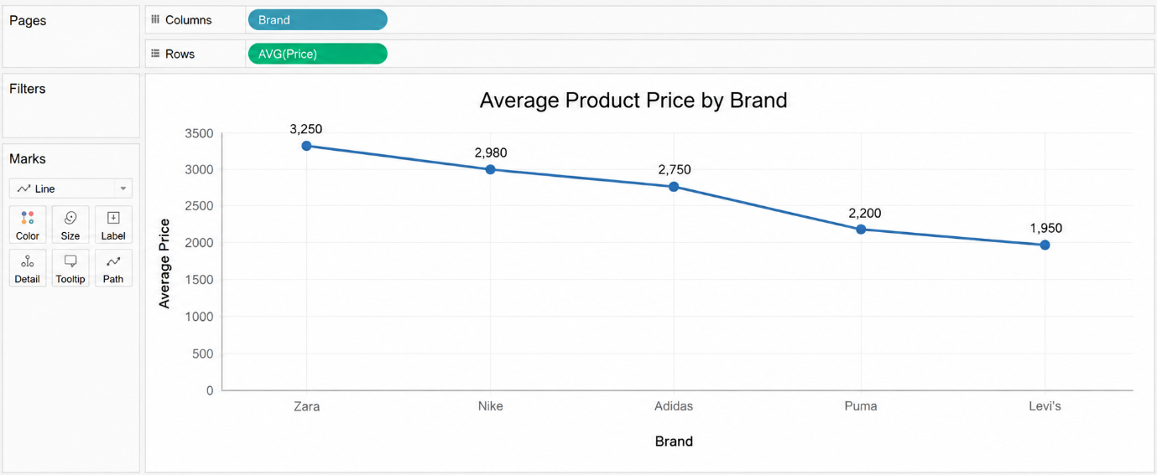

Interpretation

The line chart shows how the average product price varies across different brands.

It helps identify:

• Higher-priced brands
• Lower-priced brands
• Price variations between brands
• Brands with relatively high or low average prices
• Overall pricing patterns

Algorithm 6 – Creating Calculated Field

Objective

To calculate the price per rating point for each fashion product.

Step 1

Select:

Analysis → Create Calculated Field

Step 2

Enter the field name:

Price per Rating Point

Step 3

Enter the formula:

[Price] / [Rating]

Step 4

Click OK.

Output

The calculated field Price per Rating Point is created successfully.

Interpretation

The calculated field determines the price of a product for each rating point, helping compare the price and rating relationship among fashion products.

Algorithm 7 – Applying Filters

Objective

To analyze fashion products for a specific brand.

Step 1

Drag Brand to the Filters shelf.

Step 2

Select the required brand.

Step 3

Click Show Filter.

Step 4

Select a brand such as Nike.

Step 5

Observe the updated charts.

Example

Filter: Brand = Nike

Output

The visualizations display only fashion product records belonging to Nike.

Interpretation

The Brand filter allows users to focus on a particular brand and perform detailed product, price, and rating analysis.

Algorithm 8 – Creating Parameter

Objective

To dynamically display products based on a user-defined minimum price value.

Step 1

Select:

Create Parameter

Step 2

Specify the parameter name:

Minimum Price

Step 3

Set the data type as:

Float

Step 4

Set the required minimum value.

Step 5

Create a calculated field using the parameter.

Formula

[Price] >= [Minimum Price]

Example

Minimum Price = 3000

Output

The visualization displays products where the Price is 3000 or more.

Interpretation

The parameter allows users to dynamically identify higher-priced fashion products based on a selected price threshold.

Algorithm 9 – Dashboard Creation

Objective

To create an interactive Fashion Products Analysis Dashboard.

Step 1

Create multiple worksheets.

Step 2

Select Dashboard → New Dashboard.

Step 3

Drag the required worksheets into the dashboard.

Step 4

Arrange the charts clearly.

Step 5

Add filters for:
- Brand
- Category
- Color
- Size

Step 6

Add the Minimum Price parameter.

Step 7

Add appropriate titles and labels.

Dashboard Analysis

Total Products

Count of Product ID.

Average Product Price

Average of Price.

Average Rating

Average of Rating.

Number of Brands

Count of unique Brand values.

Number of Categories

Count of unique Category values.

Interpretation

The dashboard provides a consolidated view of product distribution, brand performance, pricing, and ratings and allows users to interactively analyze the data using filters and parameters.

Algorithm 10 – Story Creation

Objective

To present the analysis of fashion products, pricing, brands, categories, and ratings through a sequence of visual insights.

Step 1

Create the required worksheets.

Step 2

Create the Fashion Products Analysis Dashboard.

Step 3

Select Story → New Story.

Step 4

Add the dashboard and required worksheets as story points.

Step 5

Arrange the story points in a logical sequence.

Step 6

Present the findings.

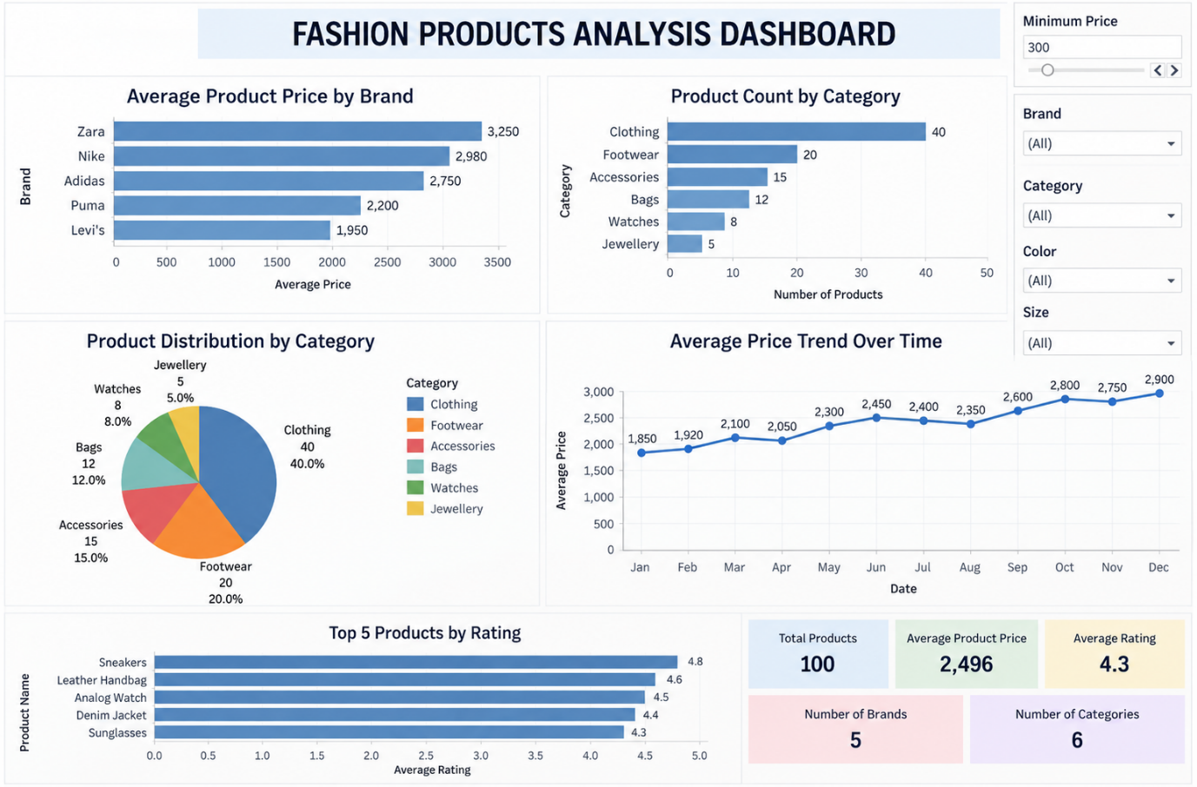

Example Story

Story Point 1 – Overall Fashion Products Analysis

Displays total products, average product price, average rating, number of brands, and number of categories.

Story Point 2 – Average Product Price Analysis

Shows how the average product price varies across different brands.

Story Point 3 – Category-wise Product Analysis

Compares the number of products across different categories.

Story Point 4 – Category-wise Product Distribution

Shows the distribution of fashion products across different categories.

Story Point 5 – Product Rating Analysis

Compares the ratings of different fashion products and identifies highly rated products.

Story Point 6 – Final Fashion Products Analysis

Summarizes the major pricing, brand, category, and rating patterns obtained from the dataset.

Applications

Product Management

Analysis of product names, brands, categories, prices, ratings, colors, and sizes.

Pricing Analysis

Identification of brands and products with higher and lower prices.

Product Planning

Analysis of category, color, and size distributions for better product planning.

Business Intelligence

Interactive visualization and dashboard-based fashion product analysis.

Decision Making

Identification of important brands, categories, price ranges, and highly rated products for better business decisions.

Market Analysis

Comparison of products across different brands and categories to understand product patterns.

Data Analytics

Interactive visualization and exploratory analysis of fashion product pricing, ratings, and distributions.

Result

